Landmarks

Name
Institution of Affiliation
Professor
Date

Landmarks
A landmark is a feature or an easily identifiable object. Landmarks help people navigate their locations or find bearing (Dong et al., 2018). France is a beautiful country and has one of the most iconic landmarks in the world. Notre Dame de Paris is famous for its unique antique and size. It has great architectural design and is the most famous Godhic cathedrals. Visiting this landmark left me with a sense of awe on the great work of architecture displayed. Arc de Triomphe is a historical site in France. It has a rich history of the French revolution and the Napoleon Wars. The landmark is impactful because it honours those who fought and perished in the two wars.
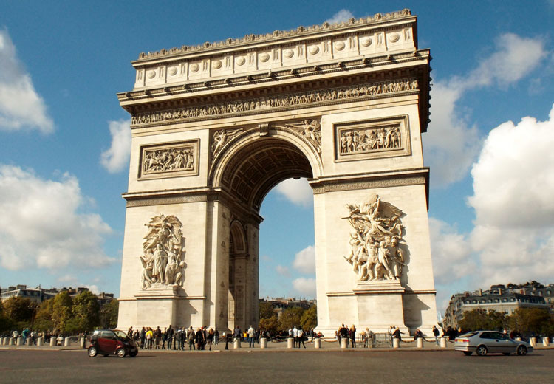
Figure 1;Arc de triomphe( Google images)
This landmark is located at the centre of Paris, France. Its construction began in 1806 and completed in 1836. The monument is 152 feet tall, 150 feet wide and 72 feet deep. At the base of each pillar are relief structures, symbolising four victories and war scenes. The top of the wall has names of major war victories for the French Revolution and Napoleon wars, while minor victories are listed inside the wall. Names of 558 generals who died are underlined on the wall. It was constructed using limestone.
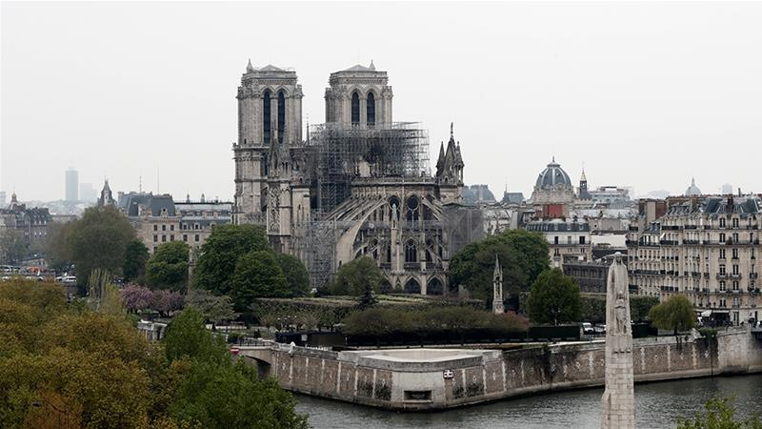
Figure 2; Notre Dame de Paris (Google images)
Notre Dame de Paris was constructed between the 12th and 14th century. The cathedral is presumed to be built on temple ruins. The western side of the dame has three portals that are sculpted with sacred scenes and saints. On the roof of this landmark are wooden frames that are made from timber. Its exterior is fitted with flying buttress that offers support to its thin walls resulting in more light for the Notre Dame. It has two towers that appear identical although the North tower is larger than the south tower. Fitted on top of the spire is a rooster that adds decoration to the cathedral. On its roof is a small beehive, honey obtained from it are shared with the poor.
In conclusion, Notre Dame de Paris is very significant to the French people. It is a symbol of the capital city since the 12th century. Among the most visited tourist attractions in the world, it is ranked among the best with over 13 million visitors annually (Ranjan et al., 2017). This tourist attraction has resulted in the growth of the economy of Paris. The cathedral offers spiritual nourishment for the community as it is the official residence for the Archbishop of Paris. Historically, Notre Dame is remembered for crowning King of France in the 1431 and for the coronation of the French empire. The community has continued to take care of this great monument especially post the fire incident, people donated to have it renovated.
Arc de Triomphe is one of the celebrated monuments in the world. It holds a rich history of the military war that happened during the French revolution and the Napoleon wars. People all over the world frequent the place to learn about history; as a result, the economy is boasted. The monument holds the French people together as it serves as a constant reminder of the generals who were vital in the past wars. Arc de Triomphe brings a lot of patriotism to the French people; as a result, the community identifies with it with a lot of pride.

References
Dong, X., Yan, Y., Ouyang, W., & Yang, Y. (2018). Style aggregated network for facial landmark detection. In Proceedings of the IEEE Conference on Computer Vision and Pattern Recognition (pp. 379-388).
Ranjan, R., Patel, V. M., & Chellappa, R. (2017). Hyperface: A deep multi-task learning framework for face detection, landmark localization, pose estimation, and gender recognition. IEEE Transactions on Pattern Analysis and Machine Intelligence, 41(1), 121-135.

